6006 Rte. 130 S., Pennsauken, NJ 08109
856-663-1700 Fax: 856-663-4465
info@interior-specialties.com

Tekon vs. Shower Guard
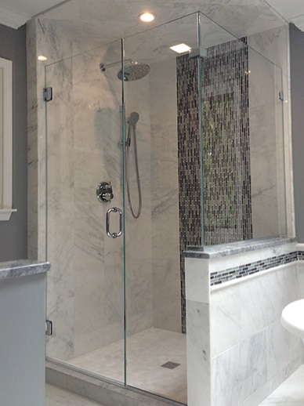

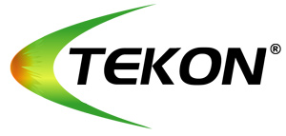
- Coating
- Applied by Interior Specialties
- Guaranteed for 3 years
- May require reapplication by the homeowner using Tekon B product (purchased from www.tekon.com)
- Less expensive
- Excellent product, no complaints received by customers in over 5 years as a dealer
- Works by creating a covalent, hydrophobic chemical bond within the glass surface to repel water, dust, and other contamination that could potentially damage the surface

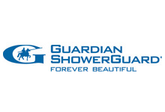
- Not a coating
- Built into glass at Guardian Industries
- Lifetime guarantee if customer registers with Guardian
- Does not require reapplication
- More expensive
- Works by using patented ion-beam technology to permanently seal the surface of the glass to resist water, dust, dirt, or other buildup that can dull or damage the surface
- www.showerguardglass.com

